Luthando Mashigo

IOT Personal Portfolio

IOT Block 3

Week 1

*Day 1*

*07/11*

**Who am I**  
Name: Luthando Mashigo

Age: 21

Bio : I am from South Africa , I study Bachelors of Computing at Belgium Campus ITVersity, I major in Software Engineering. I enjoy stuff such as making music and gaming, I occasionally code for fun but not extensively. I have programming experience in C# , C++ (IOT Perspective) , Java , Python , HTML , Javscript. Framworks : Springboot , NodeJS , ExpressJS , ReactJS and VueJS.

**What is IOT?**

The internet of things is a technology that allows us to add a device to an inert object (for example: vehicles, plant electronic systems, roofs, lighting, etc.) that can measure environmental parameters, generate associated data and transmit them through a communications network.

**ESP8266 and Coffee**

The esp8266 is quite a versatile device and it is quite cheap in both manufacturing and in price. The connection that is had , has to do with espresso as there was a micro controller could the espresso lite which was a very lightweight controller.

**Reflection**

Entered the IOT Classroom and introduced each other to the Lecturer. Learnt some concepts about IOT such as edge computing, swarm and the basic definition of Internet of Things. Also, we had a look at some hardware such as the wemos d1 mini as well as a raspberry pi 400. Also, we looked at some sensors we had provide such as temperature sensors, distance sensors and so on. Lastly for the end of the day we flashed the pi 400 in other to make a Wi-Fi server/ gateway in order to connect to it like a regular router but also establish a network based on what the pi is connected to.

Day 1 Reflections

The first day was great though we did not really get our hands that dirty with the IOT devices but overall was a pretty good day. The Lecturer is very appealing and knowledgeable in this field. I feel engaged when conversation.

*Day 2*

*08/11*

**Reflection**

Got the led to work with the wemos d1 mini. We wrote logic to the board to switch the built in led on and off. Webserver also to be configured to be able to turn on light of the other wemos d1 mini. Struggling to get the webserver. Webserver working but light not blinking yet. Looked at documentation for any guidance. I did receive help in that regard, and we managed to get the program up and running entirely. Also, we had to make a story driven IOT scenario for our aquaponics project and not just one but two as for the project we were split into two for the purposes of paired programming. The story had to be really developed and detailed.

We could not complete the any objectives to do with the second node because as shown in the Arduino ide screen we can send any requests to our server and do not understand why.

Day 2 Reflections

Not a bad day though we got to do a few things, but the day felt rushed. Also, not a major fan of having to take down notes and compile detailed documentation for everything I do.

*Day 3*

*09/11*

**Node Red introduction**

I got introduced to node red and also had to have mqtt running on my local system.

Figure : Node red local instance

Figure :Mqtt on local instance

**Reflection**

Presented the aquaponics scenario and received feedback for it. Then we continued to fumble around with IOT hardware as we began to embark on complete specific tasks such as having to configure node red via a given platform IOTempower what is remotely hosted and whereby we could collaborate on node red projects. Also, I configured and got the Arduino IDE platform to also function so the I could the flash the wemos d1 mini with specific instructions that I have coded, and it will perform those instructions. However, the IDE was configured barely on Day 2.

A major task we had to perform in pairs was to make Air Conditioner like simulator digitally via node red and using a MQTT broker to relay messages over a network which I did manage and even did some javascript functions to perform certain decion making.

However, at a certain point we were instructed to swap out some of the digital elements such as the input (temperature sensor data) with the actual sensor itself which was a major challenge as this requires knowledge of MQTT (PubSub) but also the specific sensor you are trying to read data from. We did require help in understanding how to actual use certain libraries to have the wemos d1 mini interact with the sensor and node red via mqtt and got the program working to satisfactory level.

Also, we had to make use of mqtt wildcards within node red which is the # and the +, my input came in with finding out how the hashtag worked. An example of the output is shown in the picture below, both wildcards being used and receive data.

Really a tough day as it felt like an actual workday. Playing around with the temperature sensor was fun but then trying to integrate the hardware into the AC simulator project was really difficult and took not only research but help from others who understood the concepts a little better. Class though did get tyring with all the debugging and research, and it was quite frustrating at times when I would get errors and could not figure why, or the error was extremely unclear.

*Day 4*

*11/11*

**Scaling and Testing and nice to haves**

……

**Features, Questions and recommendations**

**Reflection**

We did move on and looked to working with the other sensors such as doing a simple push button exercise for the wemos d1, though there were a couple of crashes with the program and my own Arduino Crashed and refused to work so I had to uninstall and install the latter version which ended turning out just fine. So, the thing is with the button exercise, its “sounds” simple but it was quite the challenge due to having to output a sound after the button was pressed. The thing is this had to be done via MQTT as well as we had a couple of bugs and crashes and asking for help sessions but finally on a teammate laptop, we got the program to function. My contributions had been very little during this exercise, I was more involved in building the hardware.

Also, we had to program a function to send input text from node red to an OLED display connected to the d1. The initial struggle was just getting the wiring done correctly as I was responsible for that and had to search up schematics of the OLED display just to understand how to have the thing wired to the d1. After that we got libraries and coded the webserver as well as the OLED display portion as that it was ready for use but no avail it did not work at all. I tried to see if it had something to do with the program, we flashed to the wemos but still nothing, we asked for help and still nothing. So, while my team/pair partner moved on to sending a message via node red via pushing a button. I tried a few more times with the OLED as we were losing time but eventually, I caved in and stopped and moved on to help my pair partner create the program for the button push notification.

This was our cpp setup file that was supposed to have the oled functional, but it failed.

Before further discussion of the next task of the day, this was supposed be where we give input for our oled to display.

For the push notification task we used simple push; I downloaded a simple push node and setup the node red/ MQTT side, and my partner helped me with flashing the program on the hardware to send a ping via MQTT to node red. Also, there are a few images below just to illustrate some of the explained content. The first image shows a local implementation of the task. The second and third image shows how we tackled the task as intended we had a button that we pressed and that would send a signal as indicated in the setup file so that when received by node red it can then send a push notification.

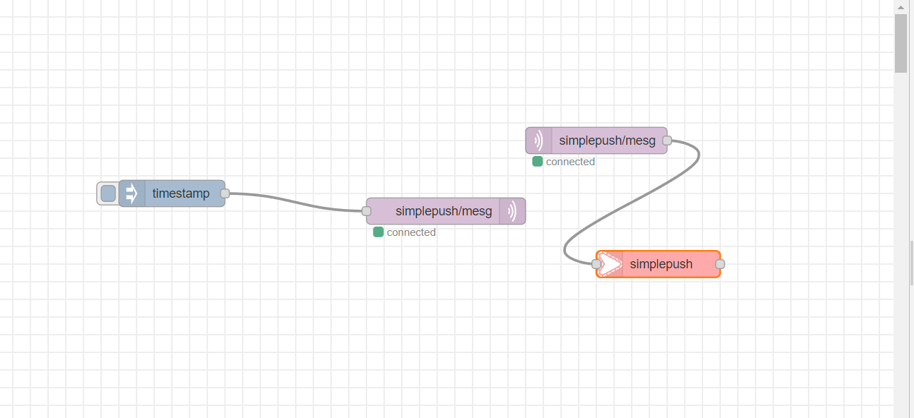

Figure : Notification – SimplePush

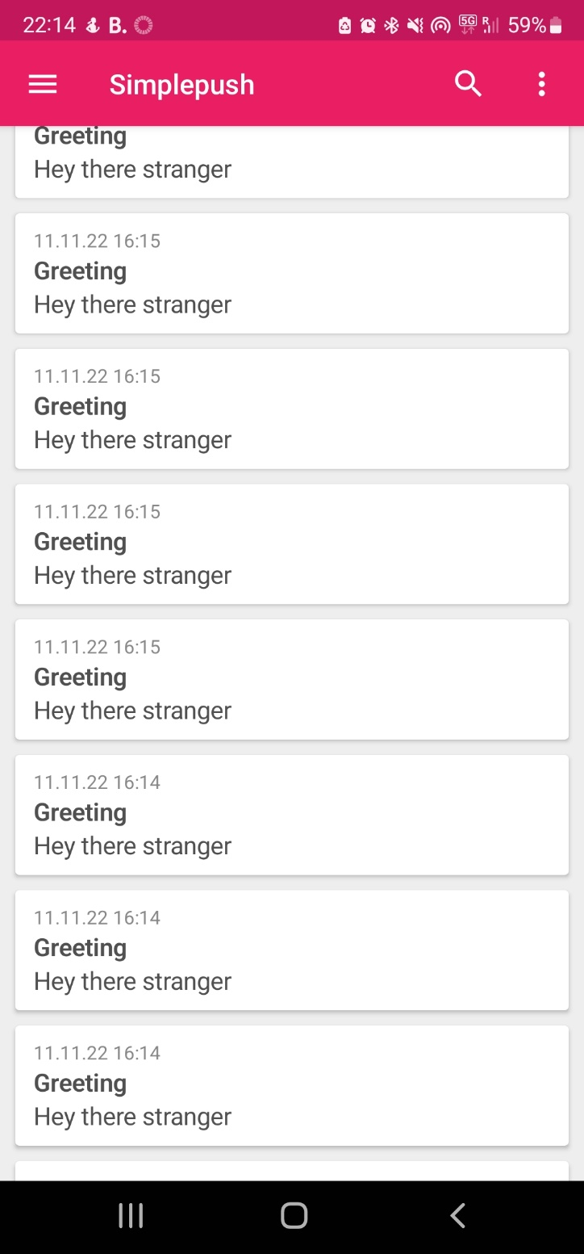

Figure : SimplePush Application, Andriod

Add text

Add moisture

Add ultrasonic

Add other 2.1.x tasks here as docs.

Day 4 Reflections

It was a really long day as well as sad and frustrating as one of our programs never full functions. So, I was not in the best mood by the end of the lecture as I do not like to leave things incomplete but due to the interest of time it had to be done. Would have loved more time but even a 9-hour work day was not enough which felt strange. However, there was pockets of upliftment during the day when the lecturer brought some nuggets of wisdom in respect to IOT which did help. Also felt like we had to rush to cover a lot of content in a short period of time and I feel like I am not getting the full experience of IOT, but I understand that we only have so much time.

Week 2

*Day 1*

*14/11*

**Reflection**

iot upgrade to be able to flash and upgrade the firmware of the pi 400. We are now partaking on completing the integration task whereby we have to build a security system with a bunch of sensors. We got assistance with upgrade the pi 400 since we were getting access denied errors. We tried completing the RFID and Distance senor task in our pairs and we had to resize the memory of the pi 400 for we had around 3.7 GB of space left, so with the space resize we have around 11 GB more of space. The resize is taking a bit of time. The resize finally worked and we got the wemos for the Distance sensor exercise. We are getting the RFID Reader wemos d1 flashed. The Wemos d1 that will be used for the RFID scanner is flashed however I am trying to research on how to send data of what the RFID reader is receiving via MQTT. Still didn’t work but because our RFID reader is actual damaged in a matter we do not understand, and we tested with another teams RFID reader and the program actual works. The lecturer tried to re soldered er the RFID reader, but it failed, and the RFID reader does not work. We are now trying to connect the relay to a female wemos but the wemos was incorrectly soldered so we are using a different one. We are now getting the relay and lock to work. We have configured the relay to function with the lock so that we could send mqtt messages from node red and receive them on the programmed wemos d1 mini with the topic Relay_Shield/Lock/set as shown in the screen shot with the node red flow.

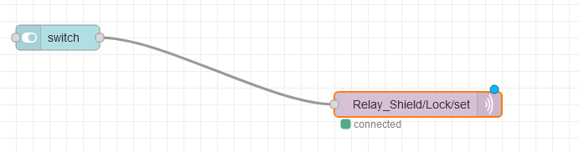

What would happen when we flip the switch in node red it would send an on signal to the topic and then the lock would respond by either locking or unlocking.

Here is our setup.cpp file for the lock.

We are building the rest of the integration with the traffic light and the rfid senor works and are able to send data via MQTT and be able to build logic to have the lights of the traffic light switch on based on certain conditions such as turning the light red for access denied and turning green for having the right key card. I wired the traffic light incorrectly by putting the red into ground instead of D2. However regardless the red light constantly remained on but we are rewiring the traffic light hardware to a female wemos. We plugged the wire meant for green into the yellow pin. We got the traffic light working and there will be images to display how the works. We are now re integrating the lock and relay and we are testing using previous complied logic. We used the wrong pin output for the logic and now it works. Our topic now was incorrect. So, we had to use D1 instead of D2 since the data line in the relay is connected to D1. Insert image of the full system.

We now trying to now integrate the buzzer and we have to use another wemos and are flashing using the PI for the initial. We are looking into the documentation. When access is granted, the buzzer does make a sound. So Lastly we have the flow that made the program function as best as it

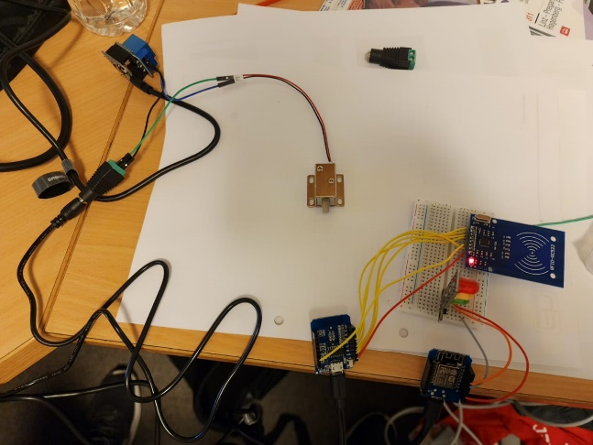

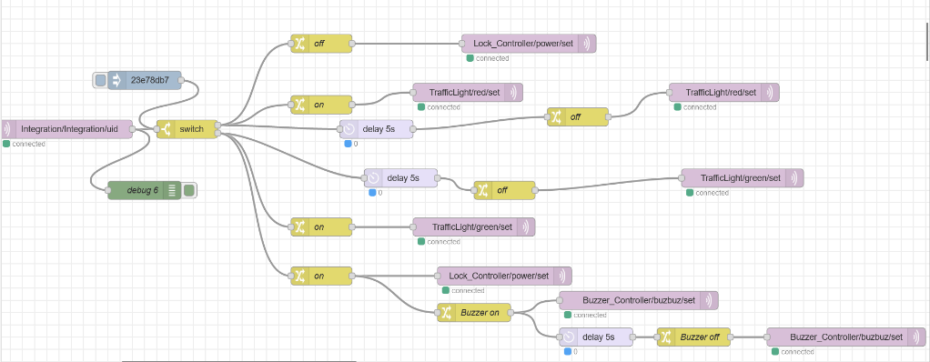

Day 1 Reflection

It was a trying day as there was a lot to do as we were wrapping up with Ulrich and we still had an integration task that we had to do. So that took a toll on me.

*Day 2*

*15/11*

**Reflection, Install WSL, Clone Repositories – SNODE.C and MQTT and Install SNODE.C**

I installed the windows subsystem for Linux which is a Debian installation and installed the libraries we were assigned to install. I also had to introduce my self as well as participate in an introductory presentation in presenting a scenario about our supposed future IOT system. After having Debian installed, I did a few exercises whereby I had to install the snode.c framework by cloning it and installing it in a local installation using Qt Creator. However, to make use of Qt Creator I had to configure the compiler to use GCC instead of Clang because I had build errors when trying to build the snode.c framework into my local projects folder. After the build was correctly completed successfully. There will be an folder with the build components alongside the original snode.c folder. After that I did an exercise where by I had to run an http client but had to run a legacy server first before I could run the client. After getting the build to work with the help of the lecturer since I was new to the snode.c framework. After that I went Qt Creator and deploy the snode.c project which install the entire framework globally , meaning on the entire sub system (root folder) so that the framework is not constrained to an interior folder. Lastly for the day after deploying the framework I had to clone another repository which is the mqtt broker repo. After that I had to build like with the snode.c framework and after the build was complete. I had to then dig with the folders of the build to find and configure the mqtt broker before I could run the broker before any messages could be sent to the broker. Use screenshots for more detail.

Day 2 reflections

The new framework was overwhelming but manageable, but I did have some fun with the subsystem within the given boundaries. Though the novelty of the subsystem did wear off toward the end of the lecturer as stuff became more challenging as a more serious approach had to be adopt and less of the experimental approach.

*Day 3*

*17/11*

**Reflection**

I was sick and unwell, but I was informed that our team had to install the snode.c framework on the Raspberry Pi.

Day 3 reflections

I have nothing much to say at the moment since I was absent.

*Week 3*

*Day 1*

**Reflection, Mqttbroker Webserver Application**

I am cloning an updated version of the snode.c framework and then also cloning an updated version of the mqtt framework. A colleague (Josias Hoffman) has received help from another team to install the updated clones of the two repos onto our raspberry pi. However, we are having troubles installing stuff system wide such as the snod.c framework but so we as a team cannot continue further but I hope to catchup later. I am learning about the mqtt broker architecture and how this links with snode.c framework but since our pi is not properly configured, I cannot continue on the actual pi.

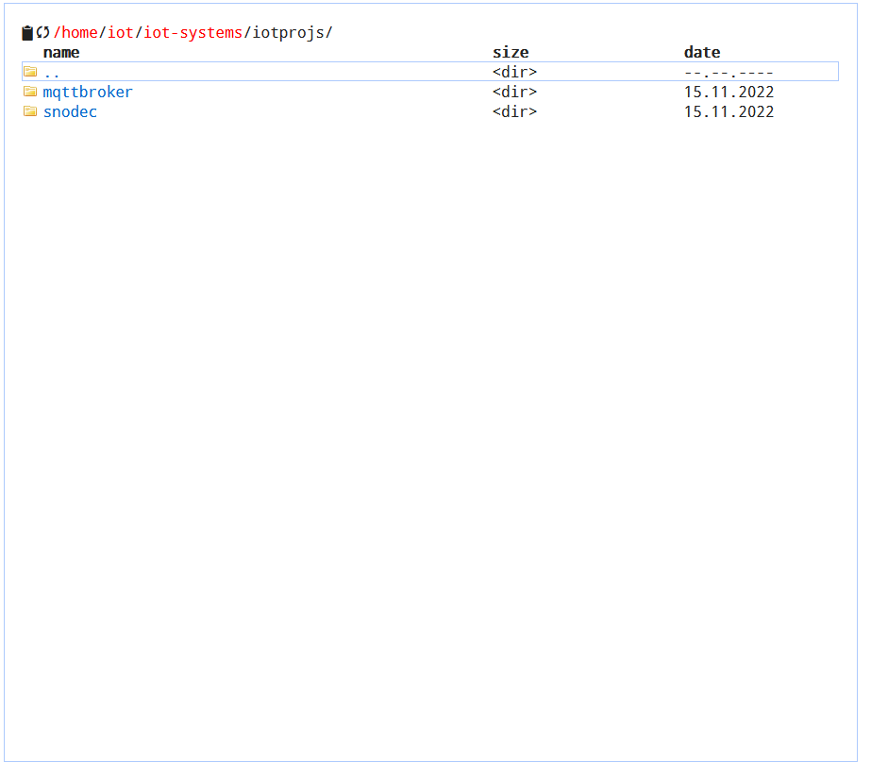

But at the end of the day I and my team had to get help from the lecture and he sent us his configured mqtt broker program and pushed it to git hub. So, I clone that updated file.

So, this is an example of the updated file cloning but on the local installation.

Day 1 Reflections

*Day 2*

*23/11*

**Reflection**

We are going to disable the mosquitto broker from running automatically on the raspberry pi. So we are going to use our mqtt broker that was coded the day before. Such as by going into the system files. Also we are trying to have node red run but we are running into issues , the starter does not function as intended, it seems it was already in use. To see how we can see what is running , we used a command , “ps -aef | grep node -red”. To make sure the snode.c and the mqttbroker files install system wide on the pi we run the command sudo “filename” make install. We had to compile the files beforehand. We focused on some project work wereby we had to implement some of the IOT concepts we learnt into our overarching project.

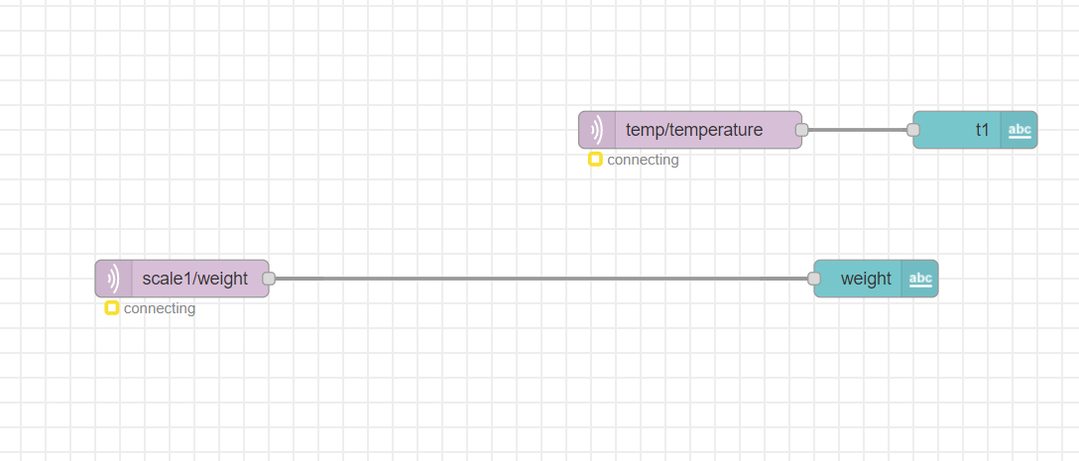

*Day 3*

*24/11*

**Investigate Public-Key crypotography**

Public key cryptography is …   
https://en.wikipedia.org/wiki/Public-key_cryptography

**Investigate X.509**

X.509 is …  
https://en.wikipedia.org/wiki/X.509pa

**Reflection**

I installed XCA which is a certificate management software and was instructed to make a root certificate and a client and server certificate. I along with my classmates explored the architecture/system of how certificates work.

I am also learning how to actually create the certificate within our local linux subsystems and not via the raspberry pi for tutorial purposes.

We are creating a certificate which will be a root CA certificate and defining its basic characteristics

We are always generating a new key

More definition we are giving to the Root CA

Summary of the details of my root CA

Now we are going to create to end certificates for web application purposes

This is my MQTT Server Certificate Summary

MQTT Client Certificate Summary

We are show two scenarios with an httpserver and the interactions with the certificates.

We are exporting the root CA using the PEM format

We are also exporting the end entity certificate (Server and Client) but we a different method which is the pem chain which has all certificates upto the root.

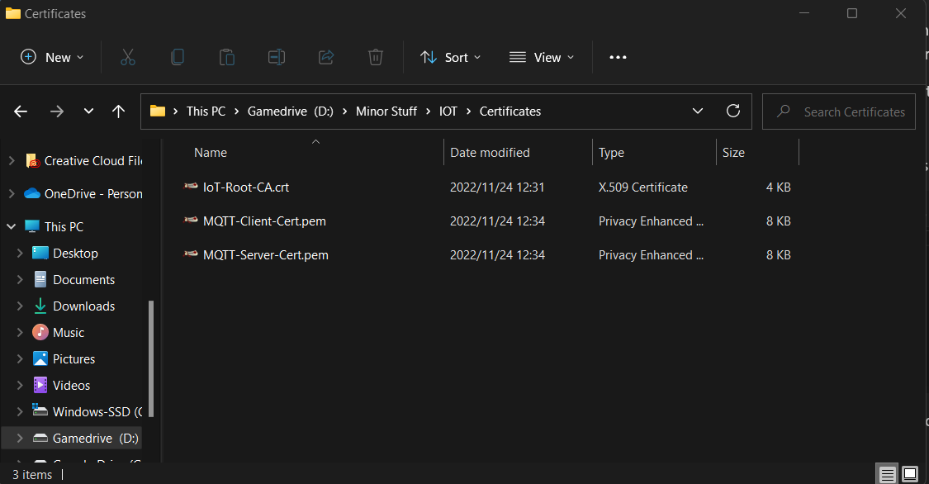

We also need to export the keys to unlock the certificates.

We export with encryption because then it is password encrypted.

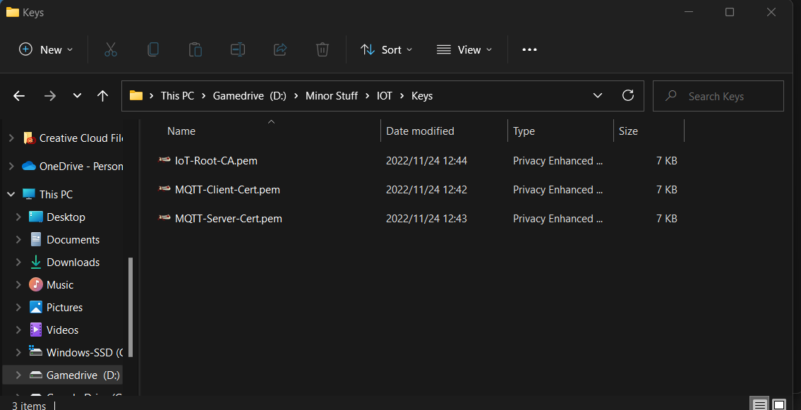

We are configure the mqtt broker to work , server with the certificates but the lectuere is busy with that. I also did part of the project implementation with some assistance such as wiring the two esp8266’s with the temperature and scale.

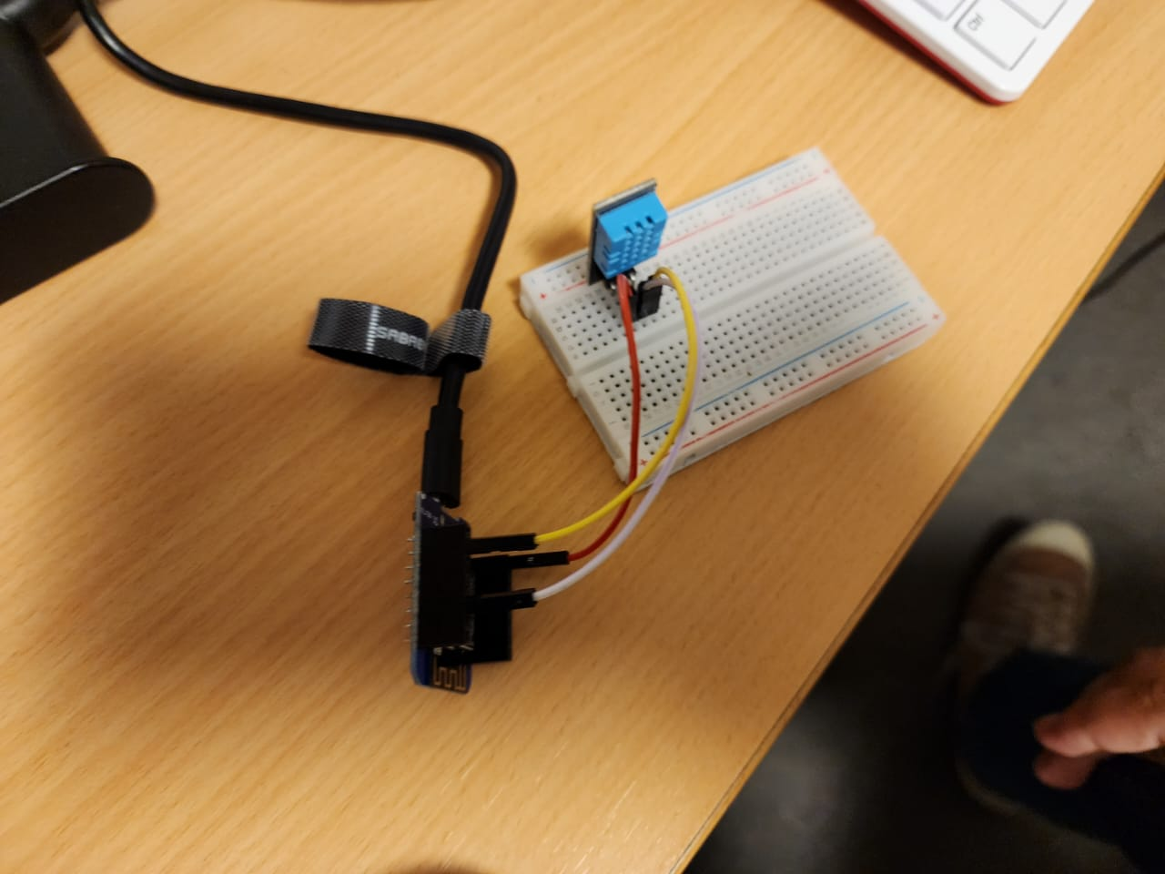

Also, I worked with my team to get node red running and have the mqtt topics configured as shown in the node red screen shot. We had to make use of the IOTEmpower framework as we had no framework of our own.

Also, along my team we flashed the two esp’s with code that would have us read the temperature , humidity and weight of the scale and pass that to node-red as shown in the setup.cpp files shown below.

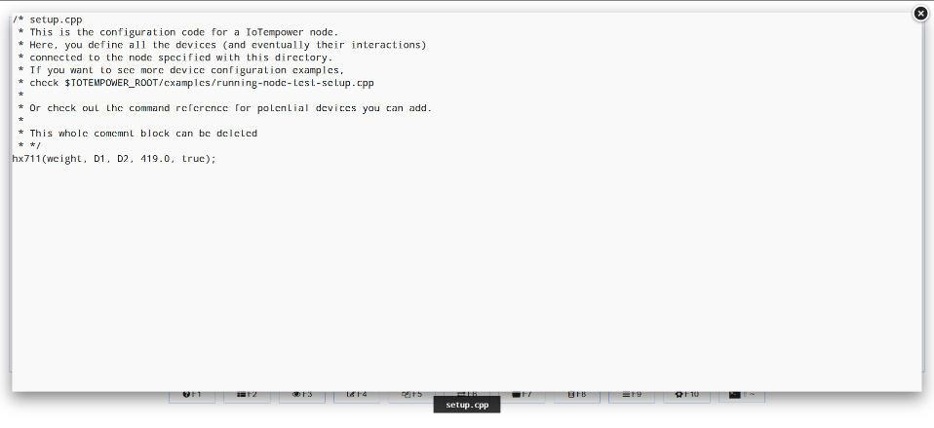

Lastly After the flashing and after receiving data we were able to pass data using these topics and having the program running and then having a temporary node-red UI as a stand in for front end display the data. I just quickly put that together since there was not enough time to fill flesh out the system.

